Russia's Responses to population ageing: mainstreaming ageing into sustainable development planning

Professor, Dr. Irina Kalabikhina
Head of Population Department,
Faculty of Economics, Lomonosov Moscow State University, Russia.

The current ageing situation in Russia and major challenges
The Russian Federation is a country with an old population and the process of ageing continues. As of 1 January 2017, the number of people over the working age is 36.7 million people or 25% of the total population of Russia. Already today, one in four Russians is older than the working age. By 2025, the proportion of citizens over the working age will increase to 27.2% or 40.3 million people. The proportion of elder persons aged over 60 is 20.7% (table 1). Among the BRICS group, Russia has the most aged population.
Table 1. Indices of demographic ageing of the Russian Federation
 | Percentage of population 60+, % | Percentage of elder persons (65 years and above), % | Median age of the population | Ageing Index: Number of persons aged 65 years and older per 100 children under 15 years of age | Percentage of the eldest persons (80 years and older), % | Aging Depth Index (80+/65+) | Number of women per 100 men aged 65 years and older
Russia, 01.01.2017 | 20.7 | 14.2 | 39.1 | 82 | 3.2 | 0.22 | 206
Source: calculated according to official statistics
The population of Russia is rapidly ageing: both the number (figure 1) and the proportion of the population 60 years and older (figure 2) will continue to grow. At the turn of the millennium, the proportion of the elder overtook the proportion of children. By 2050, the proportion of the population aged 60 and over will be 30%, and the proportion of children will remain below 20%. The median age of the population will increase from 39.1 in 2017 to 42.6 in 2030. This rapid ageing results in the need for Russia to be actively involved in the dialogue on population ageing issues and its consequences in order to prevent or mitigate the possible negative effects of ageing and to enhance the capabilities of elder persons for integrated participation in sustainable development.
The relevance of ageing issues in the context of sustainable development will increase by 2050, when 80% of elder persons live in developing countries. This situation is fundamentally different from the current situation, where at least half of the elderly population live in wealthy countries.
Figure 1. Population by age group in Russia (thousands)
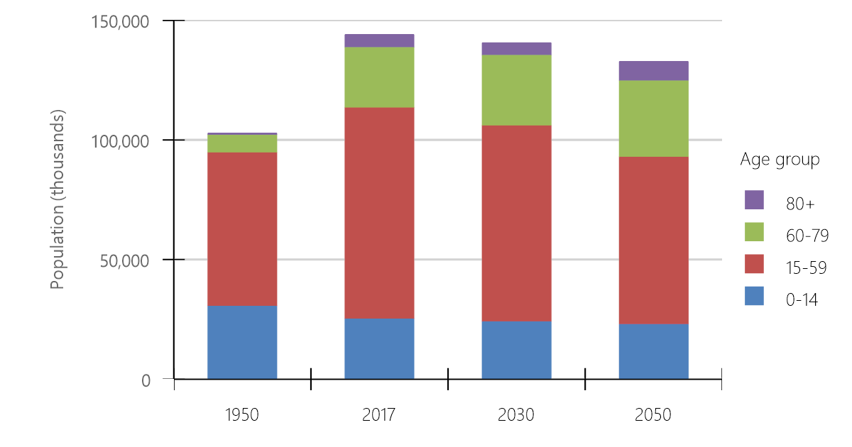
Source: Profiles of Ageing (2017). United Nations Department of Economic and Social Affairs, Population Division.

Figure 2. Population by age group in Russia (percentage)
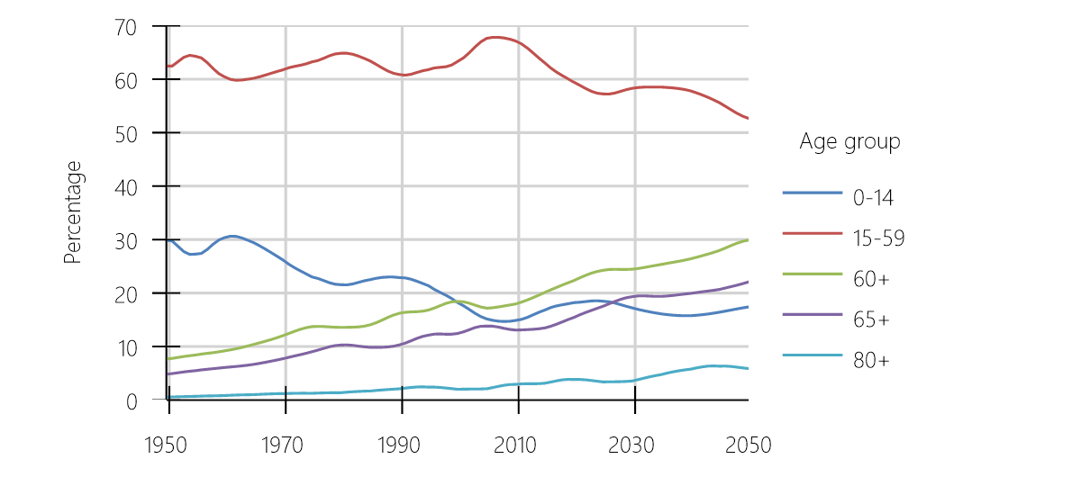
Source: Profiles of Ageing (2017). United Nations Department of Economic and Social Affairs, Population Division.

In addressing the causes of demographic ageing in Russia, it is possible to anticipate an increase in population ageing in the short term. In the 1990s, the main contribution to population ageing was the decline in fertility. Since the second half of the 2000 's fertility has grown and the main contribution was behalf the growth of life expectancy in elder ages. Life expectancy at age 60 for men and 55 years for women increased by almost 3 years from 2005 to 2016. We hope that this positive process will continue. But we are aware that this will affect the ageing of the population. Healthy life expectancy (HALE) is also growing (62 years in 2016). That is base for active ageing perspectives.
From 2017, fertility again affect the ageing of the population, accelerating the ageing process. Although the total fertility rate has increased in the last decade (from 1.2 to 1.8), the number of births has risen to 1.9 million people, an unfavourable age structure - the low number of women in adolescence and young reproductive age - will lead to a reduction in the number of births from 2017 (even if the total fertility rate is retained). These circumstances lead to the need to continue the family and demographic fertility policies in order to stabilize the level of fertility to alleviate the ageing of the population.

The potential challenges of ageing for the economy and sustainable development are manifold. The demographic dependency factor is increasing, which challenges the current pension system, healthcare, education and social support systems. According to official statistics, per 1000 persons of working age in 2018 there will be 788 dependents (333 children and 455 elderly) in 2035 - 863 (327 and 536). Even the calculation of dependency by the prospective age method shows growth of dependency in the country in the short term (table 2).
Table 2. Dependency ratios (dependents per 100 non-dependents)
 | 1980 | 2015 | 2030 | 2050
Child + old-age (ages 0-19 and 65+ / ages 20-64) | 67.2 | 53.2 | 76.2 | 81.0
Old-age (ages 65+ / ages 20-64) | 17.2 | 20.7 | 34.1 | 40.0
Prospective old-age (ages X+ / ages 20-X, where X = the age at which remaining life expectancy is 15 years) | 18.0 | 19.1 | 27.3 | 27.2
Source: Profiles of Ageing (2017). United Nations Department of Economic and Social Affairs, Population Division.
Unlike other BRICS countries the demographic window in Russia will close by 2019.
The population of working age has also aged. In 2017, the youngest group, aged 15-29 years, was the lowest percentage (29%) among the population aged 15-59 years. At the age of 30-44 and 45-59 years the population was 38 and 33%. The proportion of the population in the active innovative age 25-44 will fall dramatically.
With an ageing population and an ageing workforce, the question arises of the prospects for productivity growth at workplaces where physical work is used, of the innovative and entrepreneurial potential of the economy under the remaining old education system, when the main volume of education is given to people aged under 25 years. These circumstances require a major overhaul of the education system and the upgrading of skills on the principle of "lifelong learning" in an ageing digital society. Perhaps for Russia, with its traditionally high human potential, the prospects for a second free higher education for aspiring Russians over 40 should be considered.
An important specificity of ageing in Russia is the serious gender imbalance in the population over the working age. There are 2.4 times as many women of these ages as men. According to Rosstat, as of January 1, 2017, there were 2479 women over the working age in urban areas per 1000 men, and 2207 in rural areas.
This is due to the high overmortality of men of the working age in Russia. The gap between the life expectancy at birth of women and men is reduced by a higher rate of growth in male life expectancy during the last decade, but the gap remains high. In 2005, women lived almost 14 years longer than men, in 2016 - 10.7 years longer. During this period, women's life expectancy at birth increased by 4.6 years (from 72.47 to 77.06 years) and for men - by 7.6 years (from 58.92 to 66.50 years).
This gender imbalance leads to the risk of loneliness, lack of partnering, possible lack of access to physical assistance and social communication. As the risks of poverty at an elder age may increase, the predominance of women in the elder group can lead to inferior conditions for women.
Household living arrangements of older persons. In Russia, 14% of men and 31% of women in old age live in a single-person household (alone). The proportion of living alone is increasing - in the intercensal period (2002-2010) from a quarter to one third in northwest Russia and from a sixth to a fifth in the conservative south. Most of these households are represented by single elderly women.
Increasing of population mobility, urbanization, and alone households, the provision of household-based social support is becoming more challenging (UN 2017).
Consideration should be given to policies such as special programs to overcome male overmortality in working age, gender policy for supporting elderly single women, assessment of access of single household members to resources. There is a need for institutions and infrastructure that can serve the growing elderly single female population.
As noted by the World Health Organization (WHO) experts, population ageing together with the epidemiological transition and related lifestyle changes are among the major factors of the rising incidence and prevalence of non-communicable diseases. That is increases “the pressure on public health systems to adapt to meet the growing demand for age-appropriate care, including long-term care, services and technologies for prevention, detection and treatment of diseases”.
In order to have a healthy and integrated ageing population, it is necessary to invest in the health and material well-being of young - future elder persons. This, in our view, is the main guarantee of success in the future and the key to the success of the objectives of sustainable development.

The social and economic wellbeing of older people is relatively favourable in Russia.
According to a sample survey of population employment, the labour force in 2016 was 7.2 million people over the working age, representing approximately 10% of the labour force in the country. The employment rate of elder men and women is about 30%, and the unemployment rate is about 3%. According to the comprehensive observation of the living conditions of the population in 2016, of the 33.4% of working pensioners after the old-age pension was assigned, 15.2% worked up to 4 years, 12.6% worked for 5-9 years, 4.2% 10-14 years and 1.3% 15 years or more.
The average pensions assigned in 2016 was 12391.1 rubles per month, which amounted to 153% of the pensioner's subsistence level and 33.7% of the average wage in the country. Pensions are paid to all pensioners, and pensions are regularly indexed.
The monetary income of a member of a household in which only pensioners live was 27144 rubles per month in 2015.
93.5% of pensioners have good housing conditions and do not feel constrained. The total area per household member of pensioners is 36.04 square meters (more than the national average of 22.9 square meters).
Russia is 65th according to the Global AgeWatch Index 2015: better ranks are in Income Security (30) and Capability (25), worse ones are in Health status (86) and Enabling environment (82). Among the BRICS group (Brazil, Russia, India, China, South Africa), Russia has wide pension coverage, the most educated and aged population, on the one hand, and the reserves of growth of life expectance at 60, on the other hand.
There are, however, problems in the situation of the elderly. The legacy of the gender gap in the income of the working population is also reflected in the situation of elder women and men in the labour market. Elder working men receive a wage of 1.3 more than elder working women. The gender gap in old-age pensions is negligible.
The queue of households that are accounted for in need of accommodation are large enough (2.6 million families of veterans of all wars and pensioners in 2015).
With all the diversity of social institutions, it is not always possible for older citizens to participate in the life of society, which does not contribute to improving the quality of life of this category of people.
With a too little total number of open charity funds (301 organizations), the number of donor organizations involved in the senior generation is measured in single units.
The negative trends of age discrimination and coercion against older citizens persist in society, and there are stereotypes that reduce the role of elder persons and form a general negative background relating to senior citizens. Gender discrimination reinforces discrimination against elder persons.

Russia’s experience in responding to ageing, particularly related to mainstreaming ageing into the national sustainable development agenda and population policies in Russia
State policy in Russia supports all directions of the Madrid Plan and the Sustainable Development Goals (SDGs).
On 5 February 2016, The National strategy of Action for the interests of senior citizens in the Russian Federation up to the year 2025 was approved. On November, 2016, a plan of activities for 2016-2020 to implement the first phase of the strategy was approved.
The strategy is designed to coordinate the work of state and public institutions to address the existing problems of senior citizens. The outcome of the strategy implementation is the creation of conditions for "active longevity" of elder citizens, which will enable improving their standard of living and quality of life.
The priority areas of the Strategy are:
- financial support to senior citizens and promotion of their employment,
- improvement of the healthcare system for senior citizens, development of geriatric service, including vocational training and additional professional education in this field,
- ensuring that elder citizens have access to information and education resources,
- creation of conditions for the recreation of senior citizens,
- development of modern forms of social service, the market for social services,
- promotion of the production of goods and services to meet the needs of senior citizens,
- development of society with regards to the interests, needs and capabilities of senior citizens.
The Federal Act of 28 December 2013, No. 442-FL "On the basics of social services for citizens in the Russian Federation", entered into force on 1 January 2015. This Federal Act aims at creating a qualitatively new system of social services for citizens, including access to social services for all citizens of an elderly age, development of all forms of provision for senior citizens and persons with disabilities of social services to maintain the capability of these persons to provide for themselves and (or) provide the basic necessities of life, development of small and medium-sized enterprises in the provision of social services. The Act emphasizes per capita financing, equal and free access of citizens to social services; the proximity of social service providers to the place of residence of recipients of social services; adequacy of the number of social service providers to support citizens' social services needs; adequate financial, logistical, personnel and information resources of social service providers. Senior citizens are assisted, where necessary, in providing medical, psychological, pedagogical, legal and social assistance not related to social services (social care), which is done by involving organizations providing such assistance through inter-agency collaboration.
The federal law raises the minimum subsistence level established in the entity of the Russian Federation for the main socio-demographic groups of the population to 150% of its original size, as well as the threshold of free provision of social services to citizens in semi-stationary form of social services and at home. A common approach for all forms of social service to determine the cost of social services provided on the basis of a tariff is established.
For the first time in the field of social services foundations have been established for state financial support for socially oriented non-profit organizations engaged in social service activities. A register of social service providers of the subject of the Russian Federation has been established. An independent assessment of the quality of services is conducted. According to official Rosstat data, the total number of non-state organizations for social service of elder persons and persons with disabilities increased from 95 in 2013 to 282 in 2016.
The Federal Act of 29.12.2012 No. 273-FL "On education in the Russian Federation" guarantees the right for education without discrimination on the ground of sex, nationality or age. The right of every person for education is ensured through the creation by the authorities of all levels of appropriate socio-economic conditions to obtain it, to improve the ability to meet human needs for education of various levels and directions throughout their lives.
The strategy for the development of physical culture and sport in the Russian Federation up to the year 2020 includes a set of measures for senior citizens, including the following measures: development of physical fitness programs; creation of conditions for fitness and recreation; involvement of volunteers (instructors in physical culture and sports) to work with elder persons.
The National strategy of Action for the interests of Women for 2017-2022 (March 8, 2017 No 410-p) contains a provision that there is a large number of elderly women living alone in the Russian Federation, which entails the need to provide them with support in the form of the promotion of manageable employment, access to meaningful leisure activities, as well as other measures that contribute to their active longevity. Elder women need to maintain their capacity for self-sufficiency, physical and functional activity, and independence from external assistance in everyday life.
The promotion of employment for elder citizens is an important part of the state policy of the Russian Federation and is of great importance, both from the perspective of the income of elder persons, the use of their Educational and labour potential for the country's economy and the socialization of older persons and their integration into society.
Social support for special categories of elder citizens contributes significantly to their income levels. Senior citizens from among federal beneficiaries (veterans, disabled persons, citizens who had been exposed to radiation) are provided with monthly cash payments and state social assistance in the form of a set of social services. According to the Federal register, the recipients of monthly cash payments from the federal budget as of 1 January 2017 were about 8.8 million citizens, representing 25.3% of the total number of retirees, its average size for the Russian Federation was 2355.49 rubles, which is 7.4% higher than in 2015 (2180.81 rubles). According to data from the Pension Fund of the Russian Federation, as of 1 January 2017, the number of recipients of the social supplement to the retirement pension was over 4.0 million people, 2.12 million of them were recipients of federal social supplement to retirement pensions, over 1.88 million people were recipients of a regional social supplement to the retirement pension.
According to Rosstat data, in 2016 there were over 1277 stationary organizations in the territory of the Russian Federation, in which over 253 thousand people received social services. The overall cost of providing social services to senior citizens at residential homes (lodging houses) for the Russian Federation in 2016 was approximately 29.9 thousand rubles per person per month.
In 2016, the Ministry of Health of Russia issued for the first time an order from 29.01.2016 No. 38N "On the approval of the Order of medical assistance in "geriatrics", which the geriatric service organization is regulated by as a single system of long-term medical assistance through the continuity of guiding the patient between various levels of the health care system, as well as between healthcare and social protection services. The geriatric service model assumes a single three-tier system that includes outpatient, in-patient and organizational and methodological and scientific geriatric centers. The geriatric office in an outpatient health service is recommended to be organized if the number of attached population aged 60 and over is 20 thousand people or more. If such population is less than 20 thousand people, a geriatric office is organized. Currently, 2345 gerontological beds are operating in the Russian Federation in the network of geriatric medical assistance. On the basis of N.I. Pirogov Russian National Research Medical University of the Ministry of Health of the Russian Federation a Russian gerontological scientific and clinical center was established. The functions of the Center include organizational and methodological, scientific, curative, preventive and educational activities.
Social services provided at home are the most demanded form of social services, closest to their needs and at the same time economically reasonable. Every year, social services are received at home by 1.2 million people. This form of social services should compensate for the lack of kinship care, the inability of family members to provide care and custody to their elder relatives, but also to preserve their dwelling in their normal environment. A need to develop this form of service delivery should be noted, as demand exceeds supply, and there is still a deficit (a queue of 3.2 thousand people) on this form of services. Expenditure for providing social services to senior citizens in the form of social service at home in 2015 averaged about 4.4 thousand rubles per person per month in the Russian Federation, which is about seven times less than hospital service.
In the Russian Federation, the legislation provides for monthly compensatory payments to persons who carry out long-term care for disabled citizens and persons over the age of 80 (Decree of the President of the Russian Federation, 2006) - 1200 rubles without limiting the number of persons being cared for. Persons over 80 years of age receive an increased fixed payment to their pension to pay for permanent external care.

In order to address the problems of citizens living in rural and remote areas in a speedy and targeted manner, local social services at emergency social services offices have been introduced. "Wheeled Clinic" and "Health trains" technologies are used.
In the constituent entities of the Russian Federation, "elder-age citizens nursing schools" are being established, which enable training relatives, volunteers and others in the necessary skills for general home care for elder citizens, who cannot move on their own and serve themselves. "Security School" and "alarm button" technologies work to improve the security levels of the lives of elder persons.
In order to increase the social activity of senior citizens, promote health, expand the communication environment in some regions universities or "third-age" schools work, which are a set of social and educational programs in various areas. The acquired popular computer equipment usage skills, as well as the use of the Internet, make it easier to obtain public services for elder persons and to expand the range of communication with relatives (in social networks and via Skype).
Within the complex social policy to prepare young generations for active longevity and to mitigate the causes of population ageing in Russia, the National Strategy for the Interests of Children (2012-2017), and a Demographic Policy (2007-2025), and Family Policy (2014-2025) were implemented, the Decade of Childhood (2017) was declared.

Recommendations for further cooperation on ageing among BRICS countries
Ageing and Older Persons Matter for Development. Population ageing provides significant opportunities for sustainable development which are associated with the active participation of older generations in the economic development, unpaid care, political participation, and social capital accumulation. Older persons participate in workforce, pay taxes, consume, demand new technologies, provide unpaid care for grandchildren and other relatives, participate in economic and political life, save social traditions and peace. Policy cooperation on ageing issues and integration of elder persons into sustainable development as producers of growth and recipients of benefits can bring benefits to all BRICS countries.
BRICS countries cooperation in ageing issues may be achieved in at least four directions:
- Development of a system of indicators of population ageing in the context of political action within the implementation of the Madrid Plan of Action and the Sustainable Development Goals.
- Collaborative production, storage and processing of data on ageing processes, on the causes of ageing, on the impact of ageing on sustainable development and on the economy, on the social and economic wellbeing of older people and other age groups that will become elderly in the future.
- Collaborative research on the development of new technologies, products and services for an ageing population in digital economy.
- Exchange of successful practices through the creation of a virtual cloud of policy practices at the country and regional levels in all areas of implementation of the Madrid Plan of Action and the Sustainable Development Goals.
More on the first direction - the development of a system of indicators of population ageing in the context of political action within the implementation of the Madrid Plan of Action and the implementation of the Sustainable Development Goals.
The system of indicators of population ageing in the context of sustainable development consists of four groups (table 3):
- Ageing Process Indicators,
- Ageing Causes Indicators,
- Economic Impact Indicators,
- Wellbeing of Older and Future Older Indicators.
Thus, in the current decade, a lot has been done in the field of mainstreaming ageing into the national sustainable development agenda and population police to ensure that elder persons enjoy benefits of social and economic development in an equitable manner. However, much remains to be done in the the era of an ageing population to achieve the Sustainable Development Goals.

Table 3. System of indicators of population ageing in the context of sustainable development: Ageing Process Indicators, Ageing Causes Indicators, Indicators of the Impact of Ageing on the Economy, Indicators of the social and economic wellbeing of older people and the future elderly people.
Ageing Process Indicators |  | Ageing Causes Indicators |  | Economic Impact Indicators |  | Wellbeing of Older and  Future Older Indicators
 | Percentage of the elderly population in the country's population |  | Life expectancy in elder ages |  | Dependency ratio |  | Global Age Watch Index (GAWI)
 | Ageing Index (65+/0-14) |  | Survival rate to elder age |  | Young people (children) and elderly dependency ratio |  | Living Arrangements of elder persons
 | Ageing depth index (80/65+) |  | Number of births |  | Potential support ratio |  | Indicators for cities that are friendly to the elderly
 | Sex ratio in the elder population |  | Total fertility rate |  | Parent support ratio |  | Indicators of the wellbeing of youth (level of education; employment and unemployment; affordability of housing relative to income; health)
 | Growth rates of the entire population, the elderly and most senior population |  | Age distribution of emigrants and immigrants |  | Prospective dependency ratio¹⁴ |  | Indicators of the the wellbeing of population aged 40-59 (number of years in the education system; health; material wellbeing)
 | Median age of the population |  |  |  | Support Ratio
 | Percentage of elder persons of working age in the working population |  |  |  | First demographic dividend¹³
 | Prospective age |  |  |  | Second demographic dividend¹³
 | Proportion of elder persons with regard to the prospective age |  |  |  | Contribution of the elderly to household child care (time use, %)

At present, in the Russian Federation, the age limits of the working population for men are 16-59 years, and 16-54 for women.
The Demographic Windows (proportion of children under 15 falls below 30% and proportion of elderly over 65 is still below15%)
BRICs Monthly. Issue No: 11/05 May 31, 2011
The Global Enterprise Monitoring Report (GEM) (2012) highlights two demographic characteristics - gender and age - influencing the likelihood of entrepreneurial activity.
UN (United nations). 2017. Monitoring of population programs, focus on changing population age structure and sustainable development, in the context of the full implementation of the Programme of the Action of the International Conference on population and development Report of the Secretary-General. E/CN.9/2017/3. New York: United Nations.
Ageing, Older persons and Sustainable Development (2017). UNDP, AARP, HelpAge. Available at: https://www.un.org/development/desa/ageing/wp-content/uploads/sites/24/2017/07/UNDP_AARP_HelpAge_International_AgeingOlderpersons-and-2030-Agenda-2.pdf
Global AgeWatch Index 2015: Insight report, summary and methodology (2015). HelpAge International and the University of Southampton. Available at: http://www.helpage.org/global-agewatch/reports/global-agewatch-index-2015-insight-report-summary-and-methodology/
This paragraph draws on the materials of the Ministry of Labour and Social Protection of the Russian Federation, legislative documents and official statistics data.
Ageing, Older Persons and the 2030 Agenda for Sustainable Development (2017). UN, HelpAge, AARP.
Global AgeWatch Index 2015: Insight report, summary and methodology. (2015).
World Population Ageing 2017. Living Arrangements Interactive Data.
Measuring the age-friendliness of cities: a guide to using core indicators. (2015). World Health Organization.
Andrew Mason, 2005, “Demographic Transition and Demographic Dividends in Developed and Developing Countries”, Expert Group Meeting, UN, Mexico.
World Population Ageing 2017. Available at: http://www.un.org/en/development/desa/population/theme/ageing/WPA2017.shtml (10.10.2017)

